National Multiethnic Donor Awareness Month Tool Kit
AUGUST 2022
Download all materials and art files at LiveOnNY.org/NMDAM.

ABOUT NATIONAL MULTIETHNIC DONOR AWARENESS MONTH
National Multiethnic Donor Awareness Month takes place each August and is a time dedicated to saving and improving lives in diverse communities by advocating for those awaiting a lifesaving transplant. 75% of people waiting in for a lifesaving transplant in the greater New York City area are people of color. Because of this, the initiative focuses on healthy living habits that may prevent the need for an organ transplant while also raising awareness about the power of donation to save and heal lives in multiethnic communities.

Throughout the month, LiveOnNY is asking partners to share diverse stories of transplant recipients and heroic donors to show the transformative impact donation has on people and their families. We encourage all to learn more about organ, eye and tissue donation and to have conversations with their loved ones about their wishes. Together we can use our kindness and generosity to improve health outcomes in our communities.

EMAIL | NEWSLETTER MESSAGING
August marks National Multiethnic Donor Awareness Month, an initiative dedicated to saving and improving lives in diverse communities by creating a positive culture for organ, eye and tissue donation. 75% of those waiting in the greater New York City area for a lifesaving organ transplant are people of color. Because of this, the initiative focuses on healthy living habits that may prevent the need for an organ transplant while also raising awareness about the power of donation in multiethnic communities.
Below are some important facts about donation that impact communities of color:

- In the greater New York City area, 75% of the transplant waiting list is comprised of people of color, 89% of whom are awaiting a kidney transplant.
- Diabetes and high blood pressure are the leading causes of kidney failure in people of African descent.
- While people of color are more likely to need a lifesaving transplant, we are less likely to choose organ donation as part of our final wishes.

This month, take time to have a conversation about your wishes with your family. Together we can improve health outcomes in our communities. For more information about organ, eye and tissue donation, visit LiveOnNY.org.

SHORT-FORM NEWSLETTER COPY
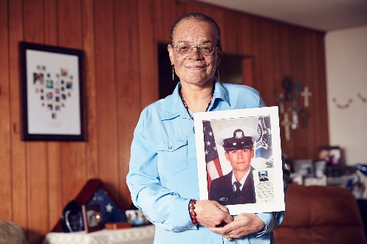
Roxanne suffered a silent heart attack. A heart transplant saved her life. Today she honors her donor and advocates for organ donation. August marks National Multiethnic Donor Awareness Month, an initiative dedicated to saving and improving lives in diverse communities by creating a positive culture for organ, eye and tissue donation. 75% of those waiting in the greater New York City area for a lifesaving organ transplant are people of color. While people of color are more likely to need a lifesaving transplant, we are less likely to choose organ donation as part of our final wishes. Take the time this month to have that important conversation about organ and tissue donation. Visit LiveOnNY.org for more information.

SOCIAL MEDIA CONTENT & GRAPHICS

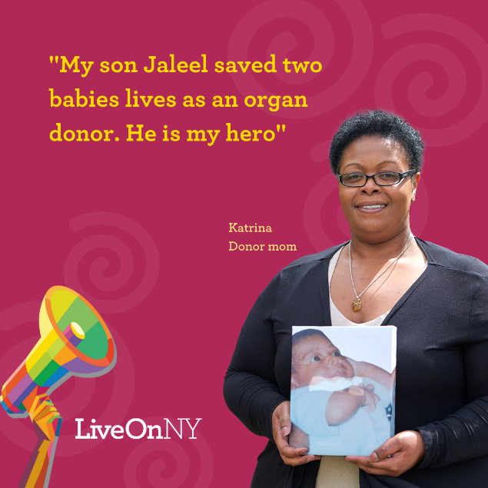
Katrina made the heroic decision to donate her son Jaleel’s organs. Her son saved the lives of two other babies. Katrina says organ donation has helped her heal and has given her a story to tell about her baby. Today she honors his legacy by celebrating his gift of life and sharing his story. National Multiethnic Donor Awareness Week began in 1996 to bring heightened awareness to donation and transplantation in communities of color. #NMDAM #LiveOnNY #DonorHero #OrganDonationSavesLives

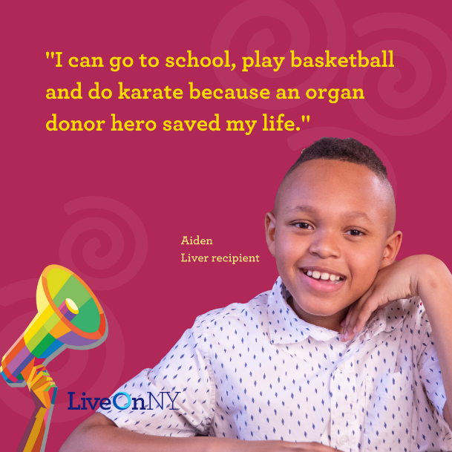
As a newborn, Aiden was diagnosed with a genetic disorder that damaged his liver. He was so sick that a simple cold could land him in the hospital. Aiden would need a liver transplant to save his life. An organ donor hero gave Aiden the gift of life when he was just two years old. His liver transplant has allowed him to grow into a smart, happy young boy who enjoys karate and basketball. National Multiethnic Donor Awareness Week began in 1996 to bring heightened awareness to donation and transplantation in communities of color. #NMDAM #LiveOnNY #OrganDonationSavesLives

SOCIAL GRAPHICS (SPANISH & CHINESE)
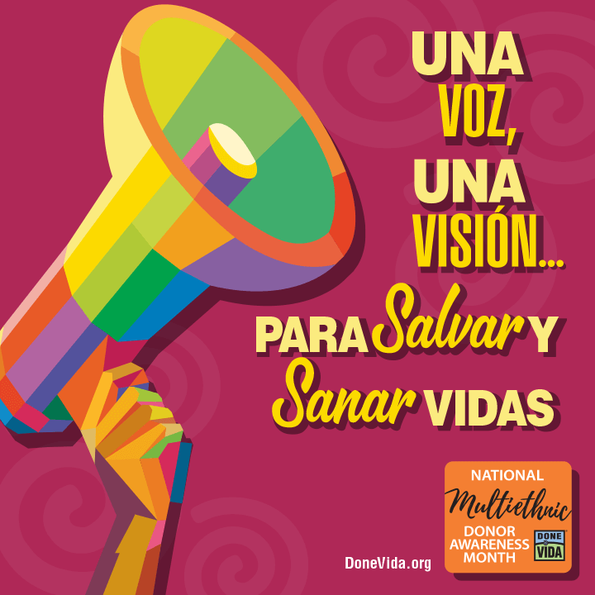

SOCIAL MEDIA COPY:
- National Multiethnic Donor Awareness Week began in 1996 to bring heightened awareness to donation and transplantation in communities of color. #NMDAM #LiveOnNY
- The majority of individuals waiting for kidneys are people of color. Americans who are African American/Black or Hispanic/Latinx are more likely to have kidney failure compared to White Americans. #NMDAM #LiveOnNY
- 75% of the transplant waiting list in the greater New York City area is comprised of people of color. Organ donation can improve health outcomes for our communities. #NMDAM #LiveOnNY
- This #NMDAM it's important to start a conversation with your loved ones about your decision to become an #organdonor. This will ensure they know your commitment and will feel comforted by honoring it. #LiveOnNY

STORIES OF DONATION: VIDEO CONTENT

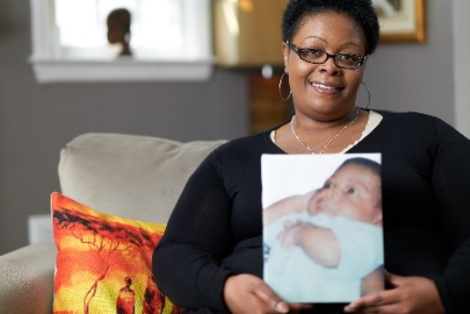
Jaleel: A Donor Hero
https://www.youtube.com/watch?v=UyuS1of71fU
Katrina made the heroic decision to donate her son Jaleel’s organs. Her son saved the lives of two other babies. Katrina says organ donation has helped her heal and has given her a story to tell about her baby. Today she honors his legacy by celebrating his gift of life and sharing his story.

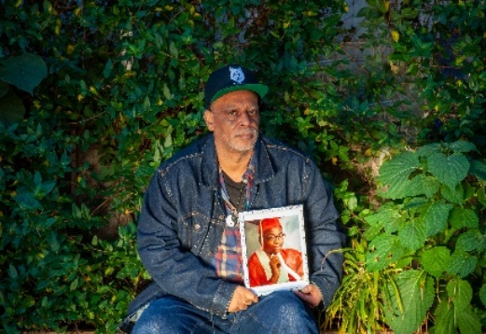
Nicholas: A Donor Hero
https://www.youtube.com/watch?v=TNWCdARH6dk
Nicholas was just 14 years old when he was tragically struck and killed by a car. In the years since Nicholas’ passing, his father Eddie shares that organ donation has brought his family comfort. Knowing that his son saved lives, helps ease the pain of his loss. Today, Eddie shares his story to honor Nicholas' gift of life and to encourage others to say yes to organ donation.

Roxanne Lives On: Heart Recipient https://www.youtube.com/watch?v=p26y7QjYZHY
Michael was a E3 Firefighter in the Coast Guard. At 23, an accident took Michael's life. He saved five lives through organ donation. Roxanne received his heart after suffering a silent heart attack. She uses her second chance at life to raise awareness about the power of organ donation and has signed up more than 12,000 organ donors over the past 10 years.

