Moment of Gratitude Tool Kit

About Moment of Gratitude
On Friday, April 29, the last day of Donate Life Month, LiveOnNY will enlist members of the donation and transplantation community to observe a Moment of Gratitude in recognition of all organ and tissue donors who selflessly gave the gift of life.

We are asking all partners to engage their staff in taking a moment to collectively remember donors. This can be done via a PA announcement, gathering staff in a meeting or whatever setting is most suitable for the organization. If your schedule precludes your team from doing this at the designated time, we ask that you please find a time or date that works best for you.

Please use the materials below to hold a Moment of Gratitude with your staff.

Materials
- Script for Moment of Gratitude to be read before the moment of silence
  - Today, in recognition of Donate Life Month, we pause to pay tribute to the selfless individuals, both children and adults, who have saved lives through organ and tissue donation. On this day and in this moment, we join for a moment of gratitude -- a moment of silence to reflect upon the heroic act of donors, the courage of their families and the renewed health and happiness of those fortunate enough to receive these very precious gifts.

- Social Media Posts
Use the following social media post on April 29th. Feel free to post your own messages in the days leading up to the Moment of Gratitude. Please use the hashtags #momentofgratitude and #LiveOnNY so LiveOnNY can track participation. LiveOnNY will post our internal Moment of Gratitude on our Facebook and Instagram pages (@LiveOnNewYork) for any organizations that wish to share.

  - Facebook:
    - Today, in recognition of Donate Life Month, join us in pausing to pay tribute to the selfless individuals, both children and adults, who have saved lives through organ and tissue donation. We share a moment of gratitude to reflect upon the heroic act of donors, the courage of their families and the renewed health and happiness of those fortunate to receive these very precious gifts. #momentofgratitude

  - Twitter:
    - Today we pause to honor the heroic act of organ and tissue donors and their families. They left a powerful legacy. #momentofgratitude
- Poem: “We Remember Them”
  - If of interest, we have attached a poem at the back of the packet that can be read at an event or flag raising, read to staff, or used in a setting that works best for your organization. If seeking additional engagement, the larger group can join in on the lines that read “We remember them.”

Social Media Graphic:
To be posted on April 29th:
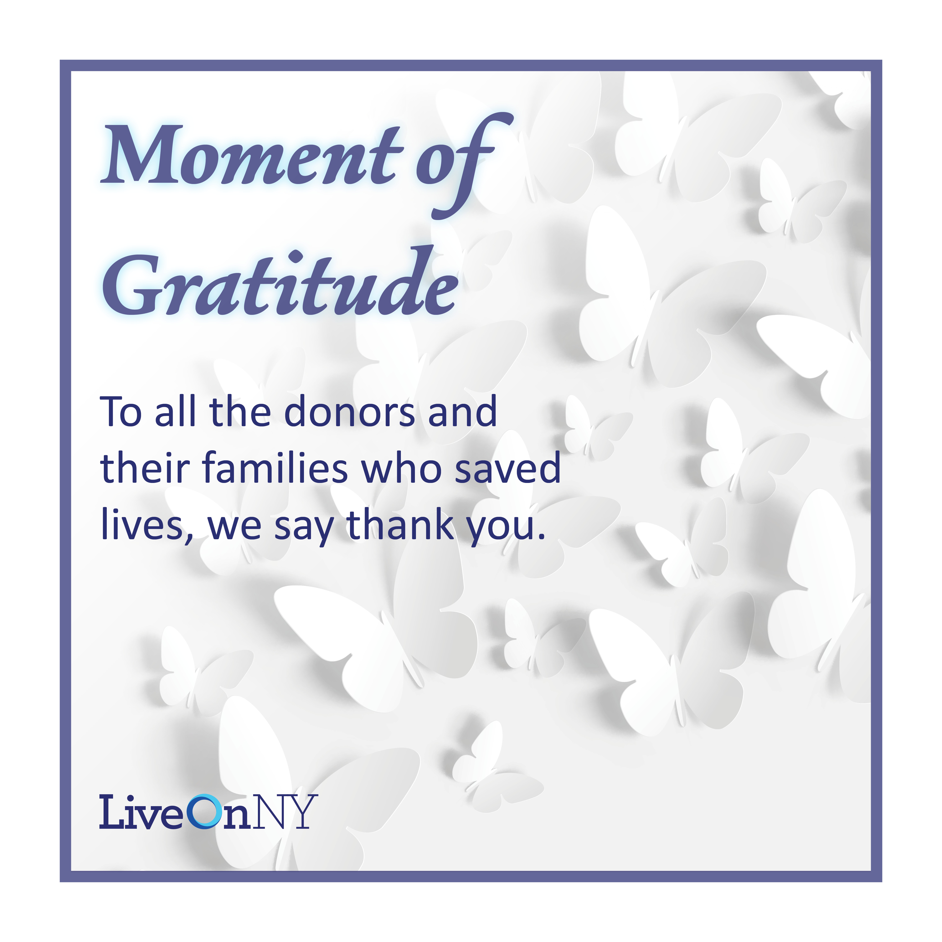

Email Template:
Please use this email template to inform your staff about the Moment of Gratitude.

Dear Colleagues,

[INSERT HOSPITAL/ORGANIZATION NAME] is proud to participate in Donate Life Month, which occurs every April and is dedicated to raising awareness about the power of organ, eye and tissue donation. Organ donation is a heroic and beautiful act that can save the lives of up to eight people. Organ and tissue donors and their families are selfless individuals who chose to give the ultimate gift so that others may have a second chance at life.

This month, medical professionals across the metropolitan area will be joining LiveOnNY and other organizations in observing a collective moment of gratitude in recognition of all the heroic organ and tissue donors. Please join us in this remembrance at [INSERT LOCATION, CLARIFY IF THIS WILL BE DONE OVER THE PA SYSTEM, OR IN A HUDDLE] at XX p.m. on Friday, April 29. If your schedule precludes you from participating at the designated time, please find time on your own to gather a few colleagues and take a moment to say thank you.

Thank you for joining to say thank you to organ donors.

Sincerely,
[INSERT NAME HERE]

We Remember Them

This is a call and response poems. Lines in italics can be joined in by all participants.

At the rising sun and at its going down;
We remember them.
At the blowing of the wind and in the chill of winter;
We remember them.
At the opening of the buds and in the rebirth of spring;
We remember them.
At the blueness of the skies and in the warmth of summer;
We remember them.
At the rustling of the leaves and in the beauty of the autumn;
We remember them.
At the beginning of the year and when it ends;
We remember them.
As long as we live, they too will live, for they are now a part of us as
We remember them.

When we are weary and in need of strength;
We remember them.
When we are lost and sick at heart;
We remember them.
When we have decisions that are difficult to make;
We remember them.
When we have joy we crave to share;
We remember them.
When we have achievements that are based on theirs;
We remember them.
For as long as we live, they too will live, for they are now a part of us as,
We remember them.

