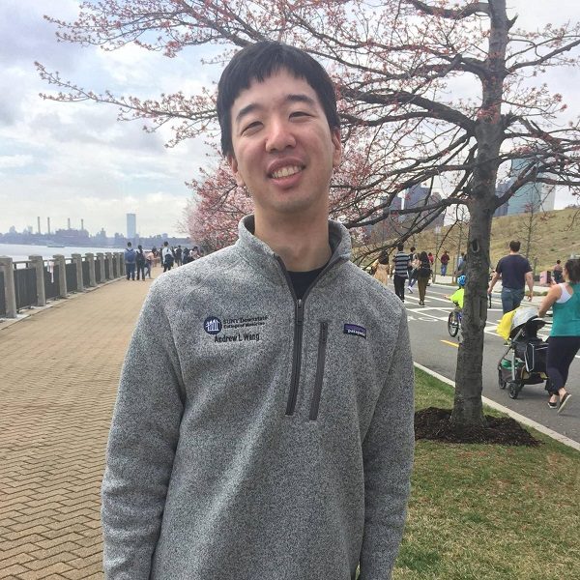
A Heart Donor Saved My Life and Changed My Family’s Perspective On Organ Donation

When I left my fifth grade classroom for a routine doctor’s visit I had no reason to think that I wouldn’t be back the next day. Things were looking up for my family and me. My parents had immigrated from China in the 1980s and had finally managed to find stable footing in the US. We purchased a home in a quiet suburb and my sister and I were looking forward to our future. That was all about to change.
While checking my heart, the doctor heard an abnormal rhythm. After a whirlwind of meetings with medical personnel filled with scary questions, I was diagnosed with idiopathic dilated cardiomyopathy. To this day, nobody knows what the cause was. No one in my family had ever had a history of heart disease.
I remember asking the nurse if I would need a heart transplant. At the time, I wasn’t sure if that was even the right word. The nurse tried to reassure me, but I could tell she was shaken and worried for my future.
I was rushed to my local hospital and then airlifted overnight to a teaching hospital far from my home. I was admitted to the ICU a few days before Christmas. A hospital Santa visited me and asked me what I wanted for Christmas. I told him all I wanted was a new heart. I remember him smiling sadly at my request.
The next few months were among the hardest in my life. My parents and sister moved closer to the hospital and my mother spent every night sleeping in my hospital room. My prognosis was so bad that the Make-A-Wish Foundation got in touch to see if they could grant me a final wish. I was only ten years old, but I understood how grim things were.
One fateful day a miracle happened, and the doctors told me I had matched with a heart donor. The next day I underwent a lifesaving operation and soon I was on the road to recovery. I am here today thanks to my incredible heart donor.
I often reflect on just how lucky I was to receive my transplant when I did. While I was in the hospital, I met another young Chinese boy my age. Our families quickly bonded because of our similar situations. He waited much longer for his transplant and during that time had a stroke that paralyzed one side of his body. There are many patients that die waiting for a lifesaving transplant.
My transplant journey had a huge impact on me and today I am an MD/PhD student in New York City. My research focuses on engineering biomaterials for drug delivery and regenerative medicine. My eventual goal is to be a practicing cardiologist so that I can help patients both in the present and the future.
It has been 15 years since my transplant and I still take immunosuppressive medications and regularly visit my cardiologist, but I live an otherwise normal life. This is all thanks to the incredible generosity of a stranger who gave me his heart when I needed it most.
Not everyone is as lucky as I am. There is a huge shortage of organ donors, especially in the Chinese community. Before my hospitalization my parents were very skeptical about registering to be organ donors because of the questionable practices and cultural attitudes about donation back in China. My transplant journey changed their minds and taught us how important it is to be an organ donor. I encourage everyone to learn more about the power of organ, eye and tissue donation and to consider signing up to be a lifesaving organ donor.
August marks National Multi-Ethnic Donor Awareness Month, an initiative dedicated to saving and improving lives in diverse communities by creating a positive culture for organ, eye and tissue donation. 75% of those waiting in the greater New York City area for a lifesaving organ transplant are people of color. Because of this, the initiative focuses on healthy living habits that may prevent the need for an organ transplant while also raising awareness about the power of donation in multicultural communities. To learn more, please visit LiveOnNY.org.

