National Multiethnic Donor Awareness Month Tool Kit
ABOUT NATIONAL MULTIETHNIC DONOR AWARENESS MONTH
National Multiethnic Donor Awareness Month takes place each August and is a time dedicated to saving and improving lives in diverse communities by advocating for those awaiting a lifesaving transplant and by creating a positive culture for organ, eye and tissue donation. 75% of people waiting in for a lifesaving transplant in the greater New York City area are people of color. Because of this, the initiative focuses on healthy living habits that may prevent the need for an organ transplant while also raising awareness about the power of donation to save and heal lives in multiethnic communities.

Throughout the month, LiveOnNY is asking partners to share diverse stories of transplant recipients and heroic donors to show the transformative impact donation has on people and their families. We encourage all to learn more about organ, eye and tissue donation and to have conversations with their loved ones about their wishes. Together we can use our kindness and generosity to improve health outcomes in our communities.
EMAIL MESSAGE
August marks National Multiethnic Donor Awareness Month, an initiative dedicated to saving and improving lives in diverse communities by creating a positive culture for organ, eye and tissue donation. 75% of those waiting in the greater New York City area for a lifesaving organ transplant are people of color. Because of this, the initiative focuses on healthy living habits that may prevent the need for an organ transplant while also raising awareness about the power of donation in multiethnic communities.
Below are some important facts about donation that impact communities of color:

- In the greater New York City area, 75% of the transplant waiting list is comprised of people of color, 88% of whom are awaiting a kidney transplant.
- Diabetes and high blood pressure are the leading causes of kidney failure in people of African descent.
- In 2020, 68% of those who received a lifesaving organ transplant in the greater New York City area were people of color.
- While people of color are more likely to need a lifesaving transplant, we are less likely to choose organ donation as part of our final wishes.

This month, take time to have a conversation about your wishes with your family. Together we can improve health outcomes in our communities. For more information about organ, eye and tissue donation, visit LiveOnNY.org.

PRINTABLE POSTERS
- 8 X 10 Print Ads (formatted for 8.5 x 11 paper) – English, Spanish, Chinese

SOCIAL MEDIA CONTENT & GRAPHICS
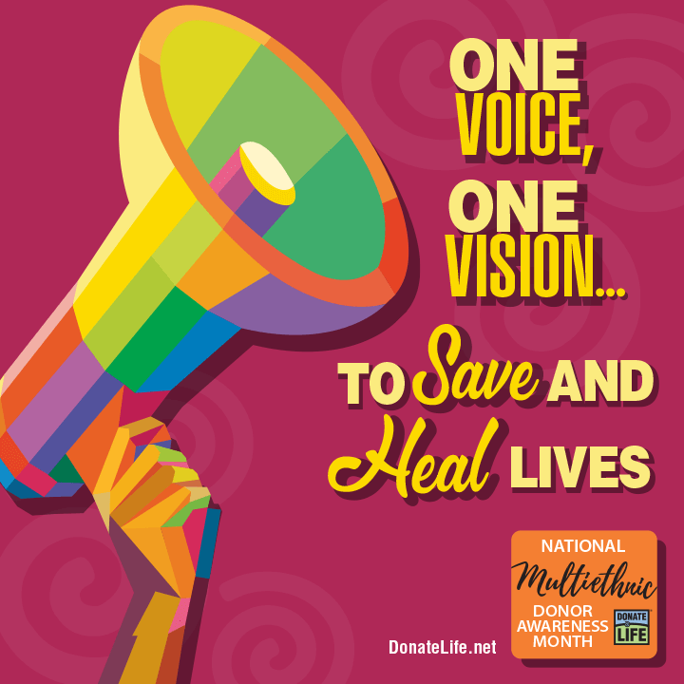
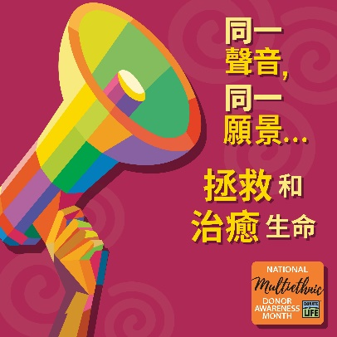
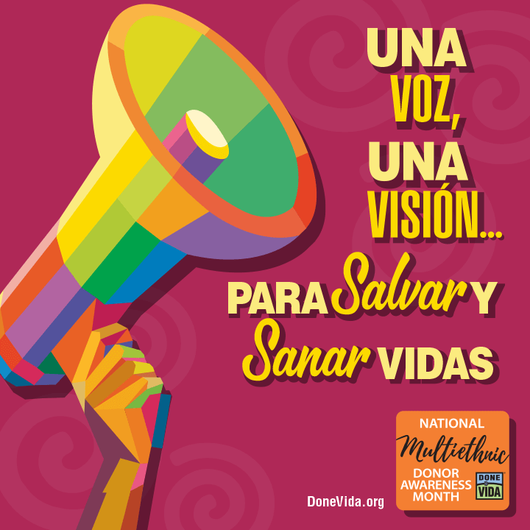

Social Graphics Content Listing:
- Facebook Post Graphic – English, Spanish, Chinese
- Instagram Post Graphic – English, Spanish, Chinese
- Twitter Post Graphic – English, Spanish, Chinese
- LinkedIn Post Graphic – English, Spanish, Chinese

Suggested Social Media Copy:
- National Multiethnic Donor Awareness Week began in 1996 to bring heightened awareness to donation and transplantation in communities of color. #NMDAM #LiveOnNY
- The majority of individuals waiting for kidneys are people of color. Americans who are African American/Black or Hispanic/Latinx are more likely to have kidney failure compared to White Americans. #NMDAM #LiveOnNY
- 75% of the transplant waiting list in the greater New York City area is comprised of people of color. Organ donation can improve health outcomes for our communities. #NMDAM #LiveOnNY
- This #NMDAM it's important to start a conversation with your loved ones about your decision to become an #organdonor. This will ensure they know your commitment and will feel comforted by honoring it. #LiveOnNY

STORY TELLING BLOG POSTS
Blogs will post weekly during the month of August to LiveOnNY-pr.medium.com. Feel free to post on your communication channels or share from our @LiveOnNewYork Facebook page on the noted dates.
Blog 1: English (scheduled to post on 8/2/21)
Subject: Kelvin, heart recipient
Overview: A lifelong athlete and father of five shares the moment he realized that a heart transplant was his only option to see his children grow up.

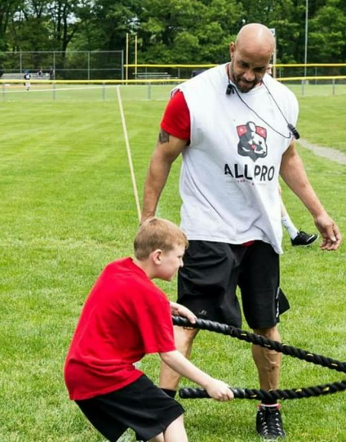
A Selfless Organ Donor Saves a Father’s Life
Kelvin was always an athlete. He played sports growing up and went to the gym every day as an adult. At age 38 he started experiencing shortness of breath, which forced him to stop working out. He went to the doctor and after a barrage of tests, they diagnosed him with restricted cardiomyopathy and said he needed a heart transplant.
“I couldn’t believe it,” he says. “I was always working out and taking care of myself and now I had a major heart problem.”

His medical team tried several other treatments before the transplant, including a pacemaker and a defibrillator, but nothing worked.

One day, Kelvin woke up in pain at the bottom of a staircase at work. He had fainted and fallen. Nobody else was around and he had to climb up the stairs to call 911.

“That’s when I knew the transplant was the only option,” he says. “It was so hard telling my kids.”
Kelvin was placed on the wait list and his symptoms got worse. Breathing was so difficult that he couldn’t walk around the mall to buy his wife a Christmas gift.

“I had to get her sneakers because Foot Locker was the closest store and I couldn’t take another step,” he says.

In February 2008, he checked into the hospital.

“I knew I wasn’t leaving unless I got a new heart or died,” he remembers. “It was a very scary time, but I tried to be strong for my family.”

On April 17, 2008 Kelvin received the gift of life from a 21-year-old man in Ohio. “I woke up from the surgery and the Yankees were on the TV in my hospital room,” he remembers. “Jeter was up at bat and in that moment, I felt like I finally came back to life. It was amazing. I am so thankful to my organ donor.”

Since his transplant Kelvin has written a memoir titled “The Unlikely Candidate: An Amazing Journey of a Heart Transplant Recipient.” He is a father to 5 children and runs his own personal training business.

August marks National Multiethnic Donor Awareness Month, an initiative dedicated to saving and improving lives in diverse communities by creating a positive culture for organ, eye and tissue donation. 75% of those waiting in the greater New York City area for a lifesaving organ transplant are people of color. Because of this, the initiative focuses on healthy living habits that may prevent the need for an organ transplant while also raising awareness about the power of donation in multiethnic communities. To learn more, please visit LiveOnNY.org.

Blog 2: English (scheduled to post on 8/9/21)
Subject: Rahki, donor daughter
Overview: A physician spent her entire life saving lives and even in her passing, she continued to save lives through organ donation.

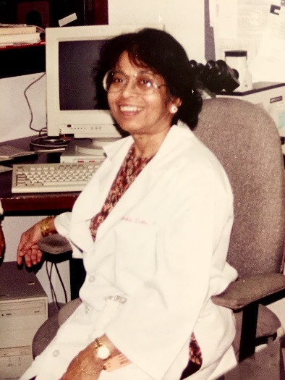
Doctor Continues to Save Lives After Her Death
Bhakti devoted her life to helping others. Born in Bangladesh in 1937, she grew up in Calcutta where she became a pathologist. She eventually immigrated to New York City in 1965 where she was a practicing physician and a devoted wife and mother.

Tragedy struck when Bhakti had a fatal stroke while gardening at the age of 70. Because Bhakti was not a registered organ donor, the decision was left up to her husband, Ranajit, and her daughter Rakhi.

“We never discussed organ donation prior to her passing. It would have been easier if we had,” Rakhi remembers. “My father and I thought about how my mother was a doctor who cared for others and was committed to helping people. All of this helped us decide to donate her organs.”

Bhakti gave the gift of life to two people, one of them was a grandfather of 12 children who went on to live for an additional eight years. Rakhi and her father had an opportunity to meet this man and his family.

“It was a very special day,” she says. “It was amazing to see that my mother’s kidney lived on in him.”

Organ donation can still be a taboo topic in the Bengali community, and Rakhi and her father set out to change that. For many years Ranajit wrote articles about the power of organ donation in the Bengali newspapers he ran. Additionally, Rakhi volunteers and shares her family’s story in an effort to educate others about the power of organ, eye and tissue donation.

“Donating my mother’s organs is one of the best decisions my family ever made,” Rakhi says. “Whenever anyone asks me about her, I get a big smile on my face as I tell them about the lives she helped.”

August marks National Multiethnic Donor Awareness Month, an initiative dedicated to saving and improving lives in diverse communities by creating a positive culture for organ, eye and tissue donation. 75% of those waiting in the greater New York City area for a lifesaving organ transplant are people of color. Because of this, the initiative focuses on healthy living habits that may prevent the need for an organ transplant while also raising awareness about the power of donation in multiethnic communities. To learn more, please visit LiveOnNY.org.

Blog 3: English, Spanish (scheduled to post on 8/16/21)
Subject: Eddie, donor dad
Overview: Organ donation brings a Brooklyn family some peace and healing after the tragic loss of their young son.
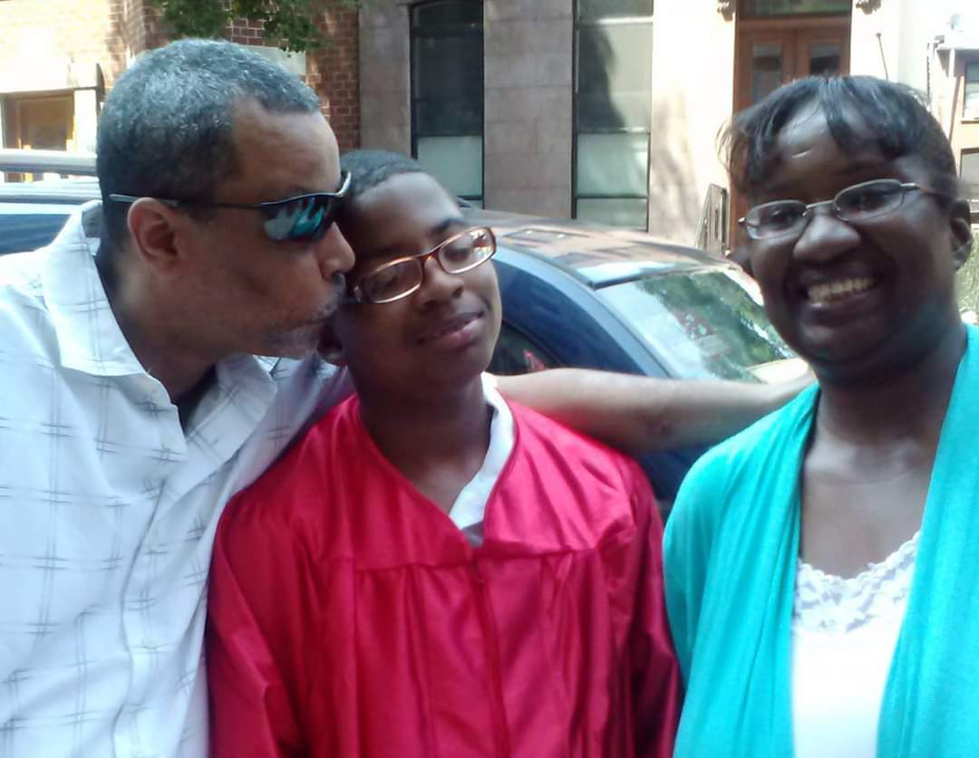
Young Brooklyn Man Saves Lives Through Organ Donation
Brooklyn resident Nicholas, 14, was a straight A student who always made the Dean’s List and spent his free time tutoring his classmates. He loved playing basketball and going to wrestling shows. Born premature, Nicholas was a fighter who his father called, “my little miracle man.”
Tragedy struck when he was hit by a car in June 2014 in Red Hook while on his way to school. When it became clear that Nicholas would not survive, his family was asked to consider donating his organs.

“Losing a child is the hardest thing,” his father, Eddie, said. “But when they asked us if we wanted to donate his organs it was an easy answer. Nicholas had a giving soul and he would want to help others have a second chance at life.”

In the years since Nicholas’ passing, Eddie says organ donation has brought his family comfort.

“I’m so proud of him,” Eddie says. “It brings me so much joy to know that he is living on in others."

These days Eddie volunteers for LiveOnNY and shares his story in the hopes that it will help other parents in his situation.

“I want people to know that you don’t have to go through this alone,” he says. “And I want them to know that organ donation is a gift not just to the recipients, but also to the donor's family. It has brought me some peace.”

August marks National Multiethnic Donor Awareness Month, an initiative dedicated to saving and improving lives in diverse communities by creating a positive culture for organ, eye and tissue donation. 75% of those waiting in the greater New York City area for a lifesaving organ transplant are people of color. Because of this, the initiative focuses on healthy living habits that may prevent the need for an organ transplant while also raising awareness about the power of donation in multiethnic communities. To learn more, please visit LiveOnNY.org.

SPANISH TRANSLATION:
Blog 3: Inglés, Español
Asunto: Eddie Soto, padre donante
Resumen: La donación de órganos trae a una familia de Brooklyn algo de paz y sanación después de la trágica pérdida de su hijo pequeño.

Joven de Brooklyn salva vidas a través de la donación de órganos
El residente de Brooklyn Nicholas Soto, de 14 años, era un estudiante heterosexual que siempre hizo la Lista del Decano y pasó su tiempo libre dando clases particulares a sus compañeros de clase. Le encantaba jugar baloncesto e ir a espectáculos de lucha libre. Nacido prematuro, Nicolás era un luchador al que su padre llamaba "mi pequeño hombre milagro."
La tragedia golpeó cuando fue atropellado por un automóvil en junio de 2014 en Red Hook mientras se encontraba de camino a la escuela. Cuando quedó claro que Nicolás no sobreviviría, se le pidió a su familia que considerara donar sus órganos.

"Perder a un hijo es lo más difícil", dijo su padre, Eddie Soto. "Pero cuando nos preguntaron si queríamos donar sus órganos fue una respuesta fácil. Nicolás tenía un alma dador y querría ayudar a otros a tener una segunda oportunidad en la vida".

En los años transcurridos desde la muerte de Nicholas, Eddie dice que la donación de órganos ha traído consuelo a su familia.

"Estoy muy orgulloso de él", dice Eddie. "Me da mucha alegría saber que él está viviendo en los demás".

En estos días Eddie es voluntario para LiveOnNY y comparte su historia con la esperanza de que ayude a otros padres en su situación.

"Quiero que la gente sepa que no tienes que pasar por esto solo", dice. "Y quiero que sepan que la donación de órganos es un regalo no solo para los receptores, sino también para la familia del donante. Me ha traído algo de paz".

En agosto se celebra el Mes Nacional de Concientización de donantes múltiples, una iniciativa dedicada a salvar y mejorar vidas en diversas comunidades mediante la creación de una cultura positiva para la donación de órganos, ojos y tejidos. El 75% de los que esperan en el área metropolitana de la ciudad de Nueva York para un trasplante de órganos que salva vidas son personas de color. Debido a esto, la iniciativa se centra en hábitos de vida saludables que pueden prevenir la necesidad de un trasplante de órganos, al tiempo que aumenta la conciencia sobre el poder de la donación en las comunidades multiétnicas. Para obtener más información, visite LiveOnNY.org.

Blog 4: English, Chinese (scheduled to post on 8/23/21)
Subject: Andrew, heart recipient
Overview: A young medical resident shares his journey of transplantation and how it inspired him to go to medical school as well as educate the Chinese community about the importance of organ donation.

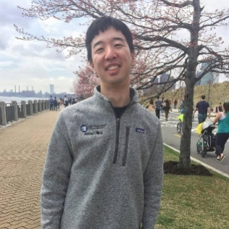
A Heart Donor Saved My Life and Changed My Family’s Perspective On Organ Donation
When I left my fifth grade classroom for a routine doctor’s visit I had no reason to think that I wouldn’t be back the next day. Things were looking up for my family and me. My parents had immigrated from China in the 1980s and had finally managed to find stable footing in the US. We purchased a home in a quiet suburb and my sister and I were looking forward to our future. That was all about to change.

While checking my heart, the doctor heard an abnormal rhythm. After a whirlwind of meetings with medical personnel filled with scary questions, I was diagnosed with idiopathic dilated cardiomyopathy. To this day, nobody knows what the cause was. No one in my family had ever had a history of heart disease.

I remember asking the nurse if I would need a heart transplant. At the time, I wasn’t sure if that was even the right word. The nurse tried to reassure me, but I could tell she was shaken and worried for my future.

I was rushed to my local hospital and then airlifted overnight to a teaching hospital far from my home. I was admitted to the ICU a few days before Christmas. A hospital Santa visited me and asked me what I wanted for Christmas. I told him all I wanted was a new heart. I remember him smiling sadly at my request.

The next few months were among the hardest in my life. My parents and sister moved closer to the hospital and my mother spent every night sleeping in my hospital room. My prognosis was so bad that the Make-A-Wish Foundation got in touch to see if they could grant me a final wish. I was only ten years old, but I understood how grim things were.

One fateful day a miracle happened, and the doctors told me I had matched with a heart donor. The next day I underwent a lifesaving operation and soon I was on the road to recovery. I am here today thanks to my incredible heart donor.

I often reflect on just how lucky I was to receive my transplant when I did. While I was in the hospital, I met another young Chinese boy my age. Our families quickly bonded because of our similar situations. He waited much longer for his transplant and during that time had a stroke that paralyzed one side of his body. There are many patients that die waiting for a lifesaving transplant.
My transplant journey had a huge impact on me and today I am an MD/PhD student in New York City. My research focuses on engineering biomaterials for drug delivery and regenerative medicine. My eventual goal is to be a practicing cardiologist so that I can help patients both in the present and the future.

It has been 15 years since my transplant and I still take immunosuppressive medications and regularly visit my cardiologist, but I live an otherwise normal life. This is all thanks to the incredible generosity of a stranger who gave me his heart when I needed it most.

Not everyone is as lucky as I am. There is a huge shortage of organ donors, especially in the Chinese community. Before my hospitalization my parents were very skeptical about registering to be organ donors because of the questionable practices and cultural attitudes about donation back in China. My transplant journey changed their minds and taught us how important it is to be an organ donor. I encourage everyone to learn more about the power of organ, eye and tissue donation and to consider signing up to be a lifesaving organ donor.

August marks National Multiethnic Donor Awareness Month, an initiative dedicated to saving and improving lives in diverse communities by creating a positive culture for organ, eye and tissue donation. 75% of those waiting in the greater New York City area for a lifesaving organ transplant are people of color. Because of this, the initiative focuses on healthy living habits that may prevent the need for an organ transplant while also raising awareness about the power of donation in multiethnic communities. To learn more, please visit LiveOnNY.org.

