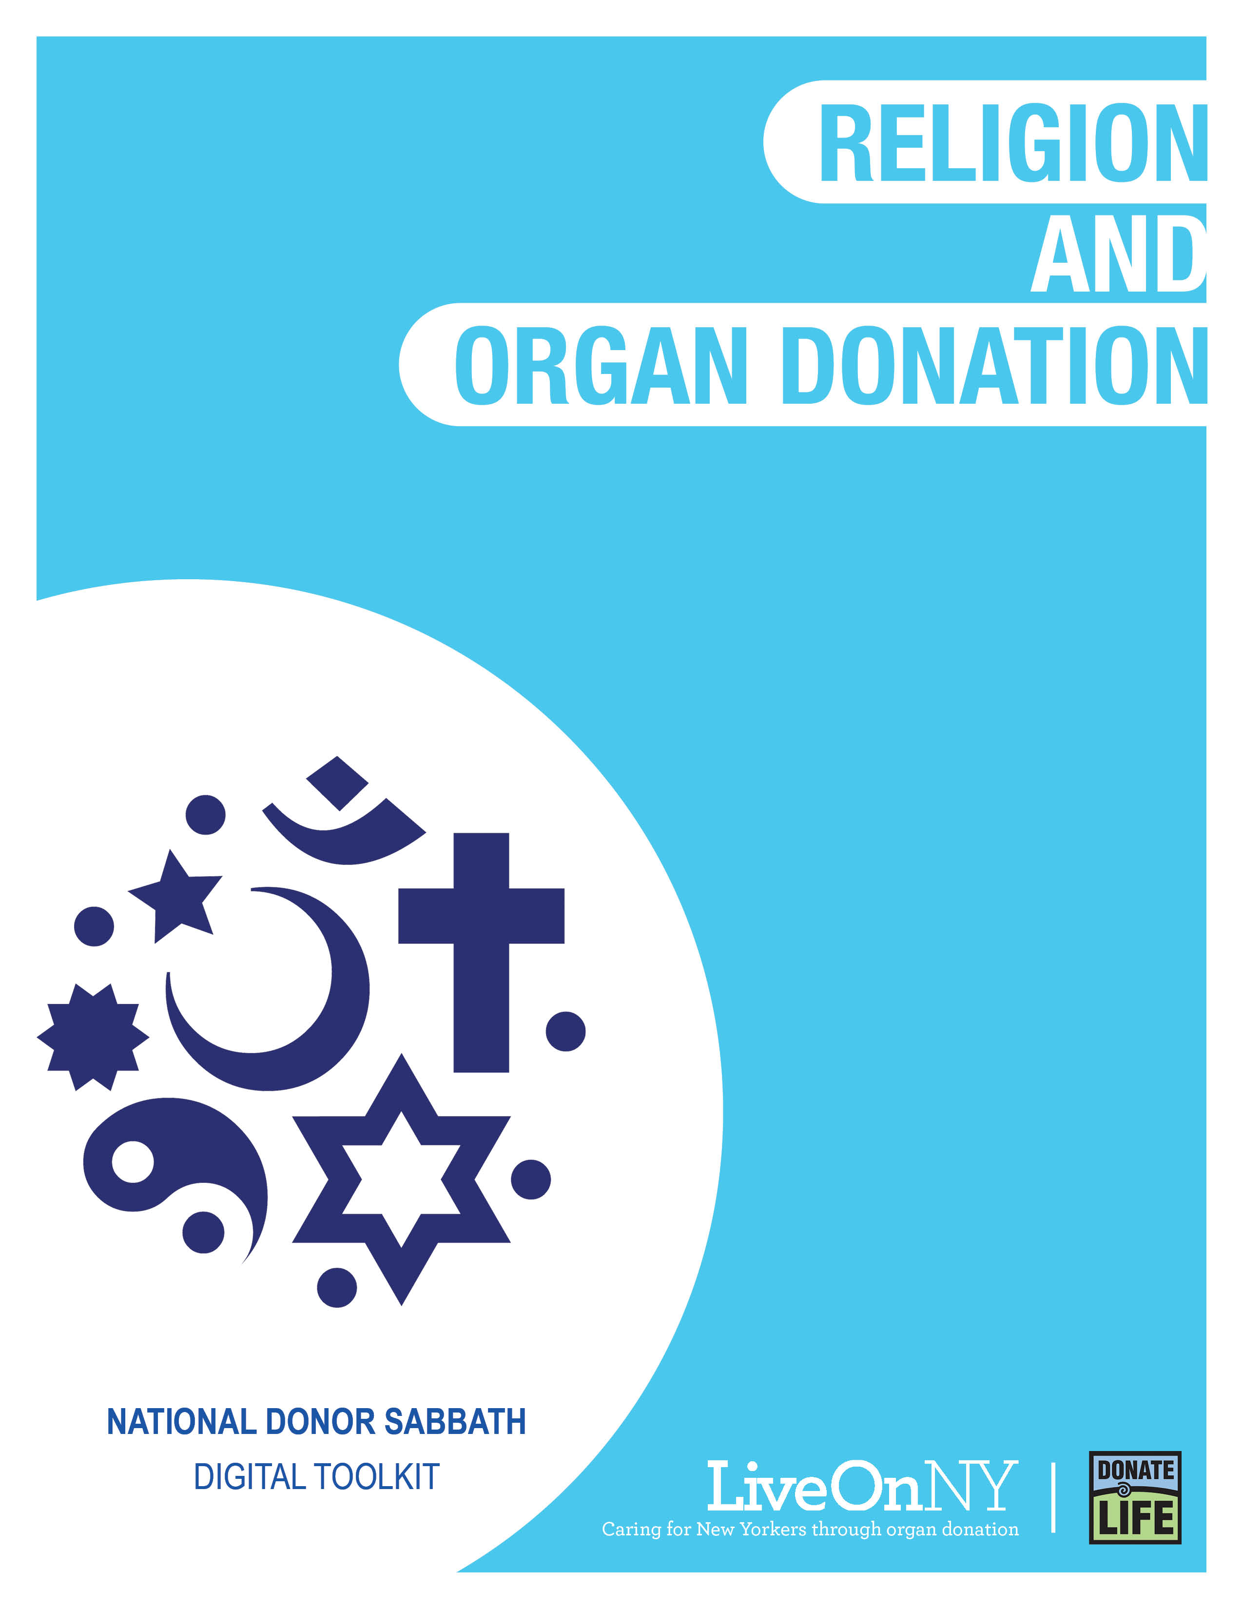

November is National Donor Sabbath month, celebrating the interfaith support of organ donation as an act of generosity and compassion that saves the lives of others.
There are 110,000 people waiting nationally for a transplant and nearly 10,000 right here in New York, many of whom may be your congregants, family, and friends. New York also has an organ shortage resulting in longer wait times for those on the transplant waiting list. On average, a New Yorker dies every day waiting for the organ transplant that could have saved their life.
Religious leaders are encouraged to affect positive change by being outspoken that organ, eye and tissue donation saves lives and extends the blessings that are given to us. By educating our communities we can encourage more people to say yes to donation and give the gift of life to someone who desperately needs it.

WHAT YOU CAN DO TO HELP
There are many ways your congregation can support and celebrate the lifesaving power of organ donation. Any of the efforts listed below will go a long way in doing something meaningful for those in need of a transplant.
- Share a message in support of organ donation during a sermon.
- Allow someone from your congregation, or another member of the community, who has been affected by organ, eye and tissue donation (a transplant recipient, someone waiting for a transplant, or the family member of someone who was an organ donor) to share their story during a sermon. If you would like to request a speaker to share their story, please submit a request here: https://bit.ly/357DmgG
- Say a prayer for those waiting for a transplant, transplant recipients, and the family members of organ donors during service.
- Feature a message in support of organ donation in your bulletin.
- Send a newsletter to your congregation.
- Write and submit an article supporting organ and tissue donation to your local newspaper.
- Post about organ donation on your social media handles and add LiveOnNY.org as a link on your website as a resource for congregants to access further information.
Below you will find resources to help you communicate the importance of organ, eye and tissue donation with your congregants. Please let us know how else we can be helpful.

Resources
Suggested Newsletter Content

Lauren, Mom, Waiting for a Heart
At age 12, Lauren was diagnosed with hypertrophic cardiomyopathy, an incurable condition that restricts blood flow from the heart. For a while she was OK, but in her teenage years the illness began to take its toll. Lauren was always an athlete, but her heart condition forced her to give up playing sports as her physical stamina weakened.
Today even the simplest task, such as getting her daughter ready for school, can bring on chest pains and force her to stop what she’s doing to rest. “Being able to see me happy and healthy again would mean a lot to my family, and to my daughter,” said Lauren.

Lauren is currently on the waiting list for a new heart. Until she gets that heart, she makes an extra effort to enjoy every minute spent with her family. She dreams of the day she gets a new heart and has the energy to teach her daughter to throw a softball or run in the park with her.

To learn more or to sign up to be an organ donor, please visit LiveOnNY.org.
The Facts About Saving Lives
- Organ donation is often possible even with certain health conditions.
- There is no age limit to be an organ donor - the oldest donor in New York was 93 years old.
- The organ donation process follows strict guidelines to ensure fairness and equity.
- Because organ donation saves lives, major religions celebrate it as a final act of kindness.
- Registering as an organ donor does not change your medical care.

Share on Social Media
National Donor Sabbath month celebrates the interfaith support of organ donation as an act of generosity and compassion that saves the lives of others as shared in this short video: https://bit.ly/2IEtzav #NationalDonorSabbath #LiveOnNY
Organ donation is an act of generosity that helps save the lives of others by giving the gift of life. #NationalDonorSabbath #LiveOnNY
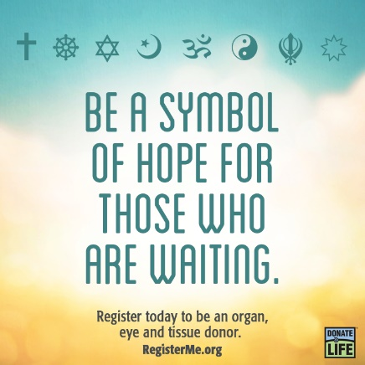

Suggested Bulletin Text
November marks Donor Sabbath, a time when we recognize the importance of organ donation. Organ donation is an incredible act of generosity and charity. One person can save up to eight lives and leave a lasting legacy. Nearly 10,000 of our fellow New Yorkers are waiting for a lifesaving organ transplant and there are not enough donors. Please consider signing up to save a life. To learn more, visit LiveOnNY.org.

Suggested Prayer
The Strength to Give: A Prayer for Organ Donation
Rock of Ages, Almighty God...
give us strength!
Give strength to those awaiting transplantation,
whose bodies betray them,
whose spirit abandons them, waiting, hoping, praying...
for the gift of life.

Give strength to the relatives and friends
of those awaiting transplantation,
who dearly love them,
who steadfastly care for them,
waiting, hoping, praying...
for the gift of life.

Give strength to the grieving families
considering organ donation.
Help them find comfort in the power
to end the wait,
to fuel the hope,
to answer the prayers...
by saying ‘yes’ to the gift of life.

Rock of Ages, Almighty God,
give our loved ones the strength to Live On...
through the miracle of transplantation
and the legacy of organ donation.

