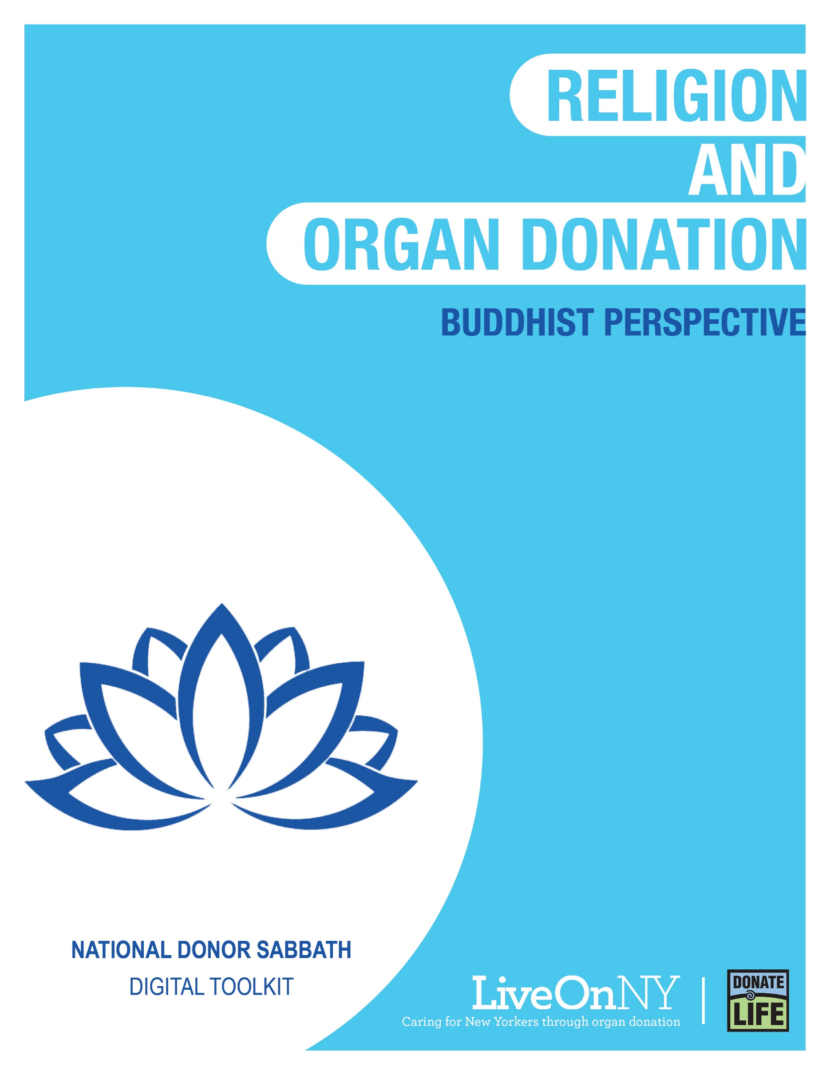

November is National Donor Sabbath month, celebrating the interfaith support of organ donation as an act of generosity and compassion that saves the lives of others.
There are 110,000 people waiting nationally for a transplant and nearly 10,000 right here in New York, many of whom may be your congregants, family, and friends. New York also has an organ shortage resulting in longer wait times for those on the transplant waiting list. On average, a New Yorker dies every day waiting for the organ transplant that could have saved their life.
Religious leaders are encouraged to affect positive change by being outspoken that organ, eye and tissue donation saves lives and extends the blessings that are given to us. By educating our communities we can encourage more people to say yes to donation and give the gift of life to someone who desperately needs it.

WHAT YOU CAN DO TO HELP
There are many ways your congregation can support and celebrate the lifesaving power of organ donation. Any of the efforts listed below will go a long way in doing something meaningful for those in need of a transplant.
- Share a message in support of organ donation during a sermon.
- Allow someone from your congregation, or another member of the community, who has been affected by organ, eye and tissue donation (a transplant recipient, someone waiting for a transplant, or the family member of someone who was an organ donor) to share their story during a sermon. If you would like to request a speaker to share their story, please submit a request here: https://bit.ly/357DmgG
- Say a prayer for those waiting for a transplant, transplant recipients, and the family members of organ donors during service.
- Feature a message in support of organ donation in your bulletin.
- Send a newsletter to your congregation.
- Write and submit an article supporting organ and tissue donation to your local newspaper.
- Post about organ donation on your social media handles and add LiveOnNY.org as a link onto your website as a resource for congregants to access further information.

Below you will find resources to help you communicate the importance of organ, eye and tissue donation with your congregants. Please let us know how else we can be helpful.

Resources
Support for Organ Donation
Organ and tissue donation is considered an individual’s decision. Buddhism does not promote or prohibit donation, but if an individual decides to become an organ donor, it is widely lauded as an act of compassion. In the case of deceased donation, the death process is an important, highly respected time for Buddhists, and the requests of the deceased takes precedence.

“I think organ donation has meanings such as life extension, internal wealth, resource regeneration, and symbiosis. Organ transplantation allows many dying people to continue their physical lives; it also allows the donor's compassionate spirit to spread. This kind of heartfelt joy and willingness to help others is the truth advocated by Buddhism.”
-Buddha-Dharma Plain & Simple” Section 310 - Venerable Master Hsing Yun

Suggested Newsletter Content

Organ Donation Saved Mary’s Life

Mary was born a healthy child, but suffered from kidney failure at the young age of three. She spent much of her early years in and out of the hospital and, at age 5, received a kidney donation from a man named Brian who gave Mary her childhood back.

Mary recovered from her transplant and attended school like any healthy kid, but then her health took a turn. When she was 12 years old, her new kidney began to fail, necessitating another transplant. This time a selfless 4-year-old and her family gave Mary a second chance at life through organ donation.

“It is 25 years later and I share my story whenever I can to raise awareness about the importance of organ donation,” Mary says. “There is not a day that has gone by that I do not think about the incredible organ donors who saved my life.”

To learn more or to sign up to be an organ donor, please visit LiveOnNY.org.
The Facts About Saving Lives
- Organ donation is often possible even with certain health conditions.
- There is no age limit to be an organ donor - the oldest donor in New York was 93 years old.
- The organ donation process follows strict guidelines to ensure fairness and equity.
- Because organ donation saves lives, major religions celebrate it as a final act of kindness.
- Registering as an organ donor does not change your medical care.

Share on Social Media
National Donor Sabbath month celebrates the interfaith support of organ donation as an act of generosity and compassion that saves the lives of others as shared in this short video: https://bit.ly/2IEtzav #NationalDonorSabbath #LiveOnNY
Organ donation is an act of generosity that helps save the lives of others by giving the gift of life. #NationalDonorSabbath #LiveOnNY
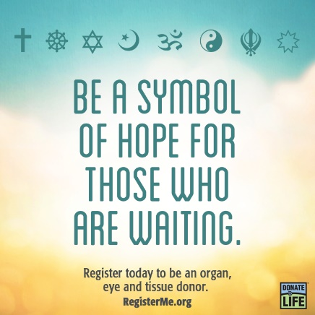

Suggested Bulletin Text
November marks Donor Sabbath, a time when we recognize the importance of organ donation. Organ donation is an incredible act of generosity and charity. One person can save up to eight lives and leave a lasting legacy. Nearly 10,000 of our fellow New Yorkers are waiting for a lifesaving organ transplant and there are not enough donors. Please consider signing up to save a life. To learn more, visit LiveOnNY.org.

