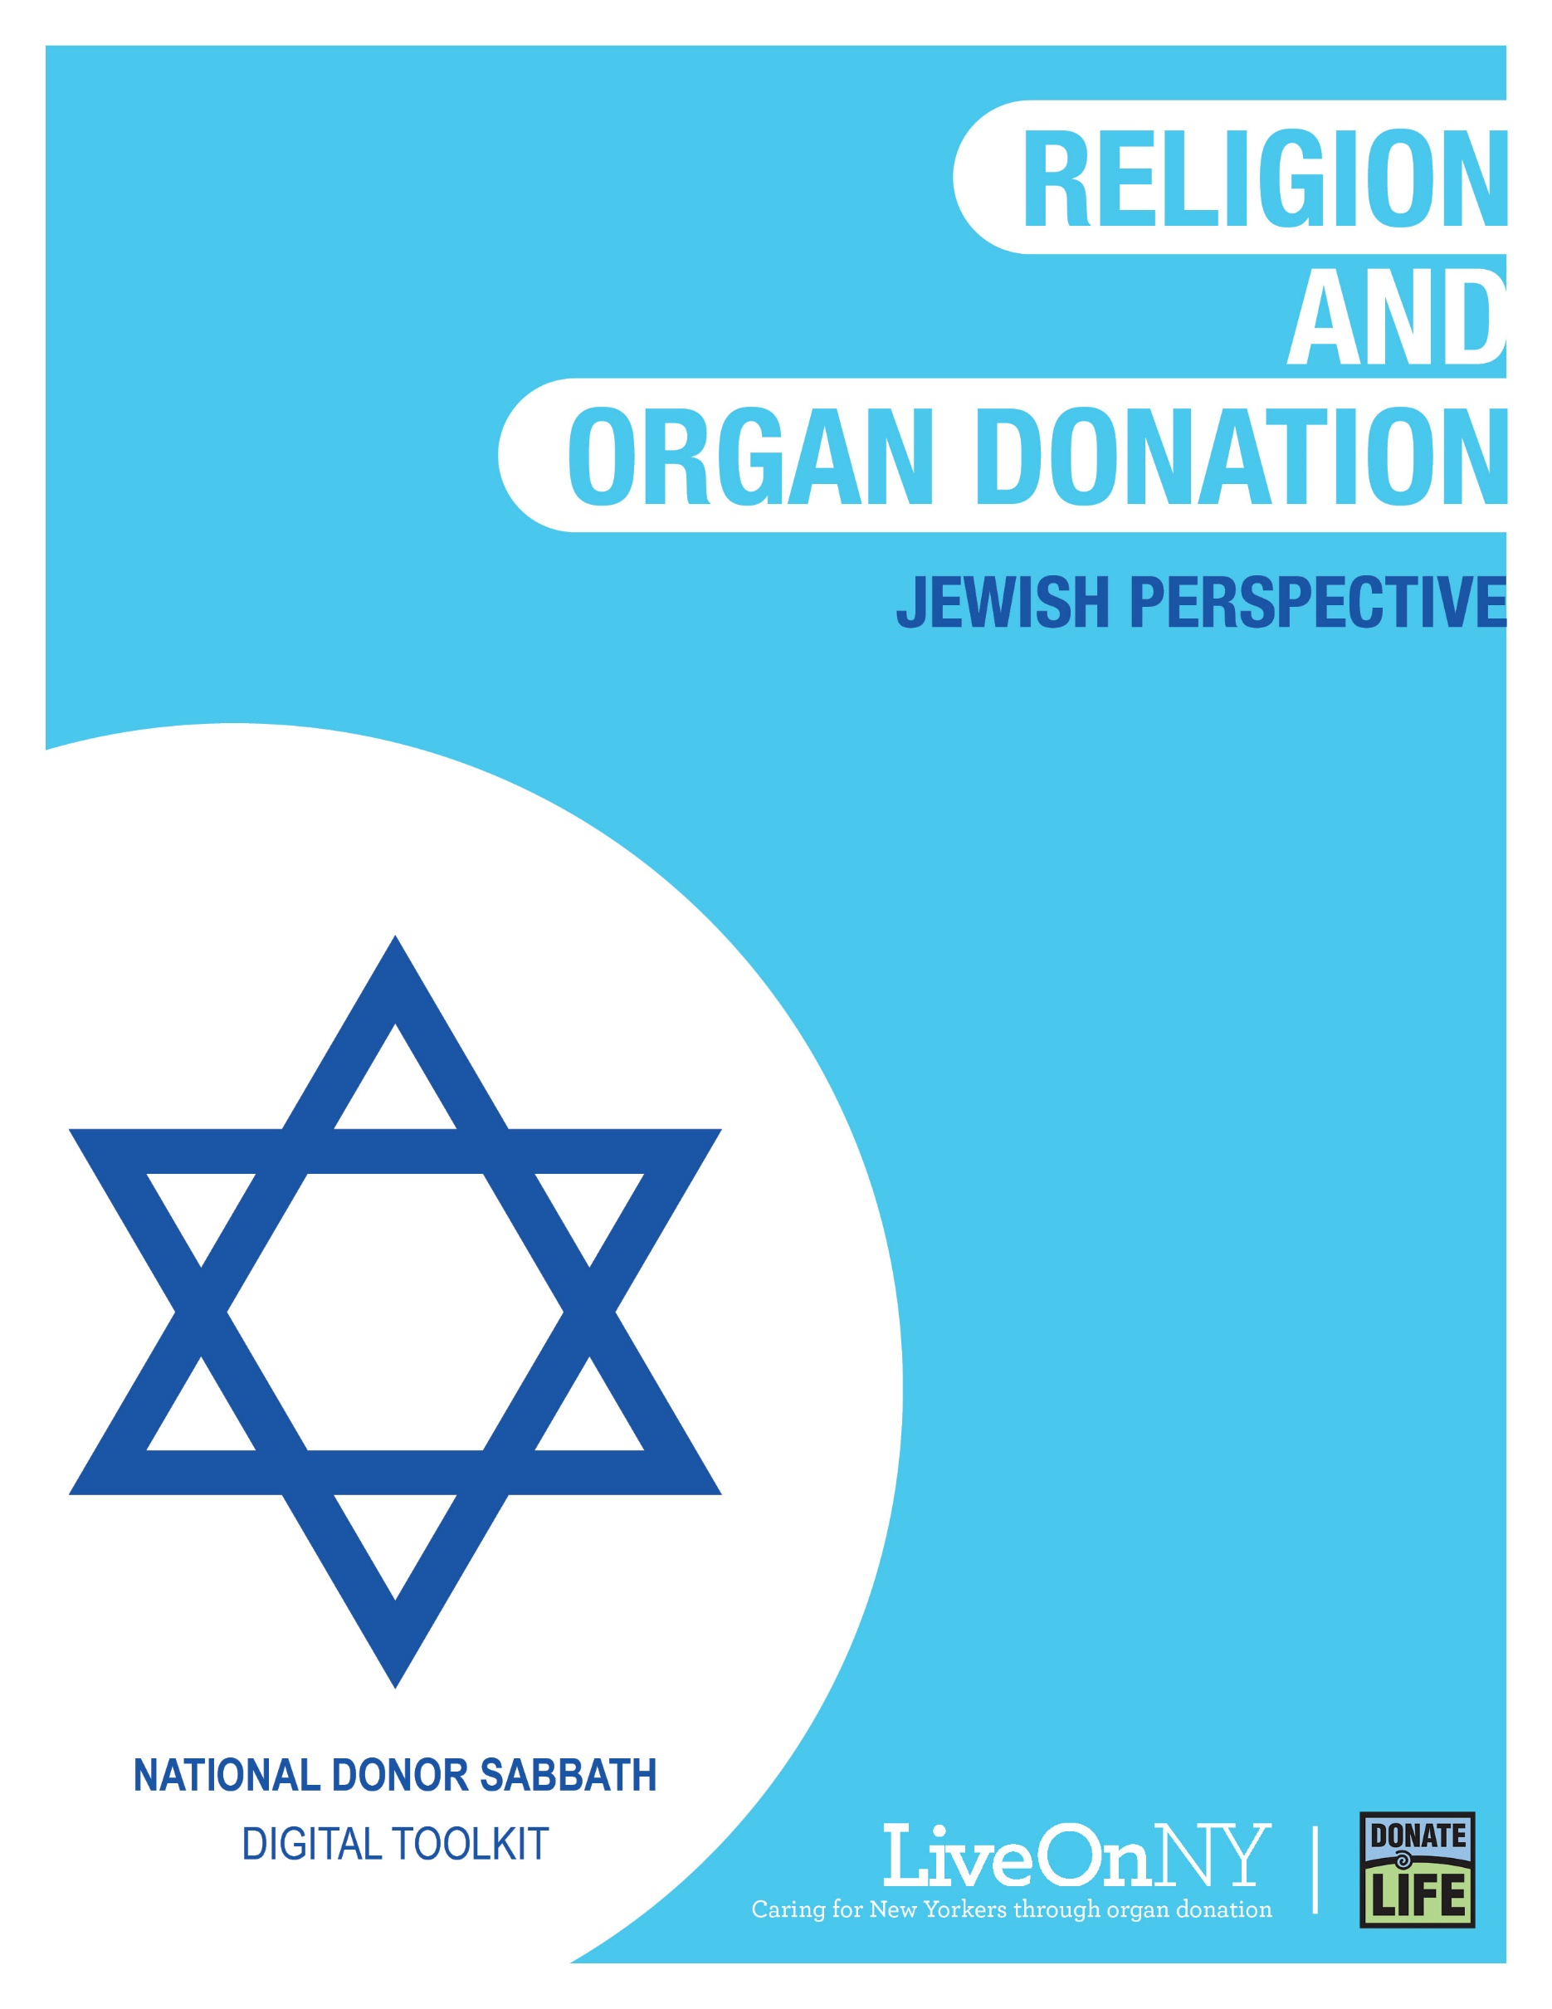

November is National Donor Sabbath month, celebrating the interfaith support of organ donation as an act of generosity and compassion that saves the lives of others.
There are 110,000 people waiting nationally for a transplant and nearly 10,000 right here in New York, many of whom may be your congregants, family, and friends. New York also has an organ shortage resulting in longer wait times for those on the transplant waiting list. On average, a New Yorker dies every day waiting for the organ transplant that could have saved their life.
Religious leaders are encouraged to affect positive change by being outspoken that organ, eye and tissue donation saves lives and extends the blessings that are given to us. By educating our communities we can encourage more people to say yes to donation and give the gift of life to someone who desperately needs it.

WHAT YOU CAN DO TO HELP
There are many ways your congregation can support and celebrate the lifesaving power of organ donation. Any of the efforts listed below will go a long way in doing something meaningful for those in need of a transplant.
- Share a message in support of organ donation during a sermon.
- Allow someone from your congregation, or another member of the community, who has been affected by organ, eye and tissue donation (a transplant recipient, someone waiting for a transplant, or the family member of someone who was an organ donor) to share their story during a sermon. If you would like to request a speaker to share their story, please submit a request here: https://bit.ly/357DmgG
- Say a prayer for those waiting for a transplant, transplant recipients, and the family members of organ donors during service.
- Feature a message in support of organ donation in your bulletin.
- Send a newsletter to your congregation.
- Write and submit an article supporting organ and tissue donation to your local newspaper.
- Post about organ donation on your social media handles and add LiveOnNY.org as a link on your website as a resource for congregants to access further information.

Below you will find resources to help you communicate the importance of organ, eye and tissue donation with your congregants. Please let us know how else we can be helpful.

Resources
Support for Organ Donation
All denominations of Judaism agree that the supreme Jewish value, and greatest mitzvah, is saving a life. Pikuach Nefesh (saving a life) is such a sacred principle that it takes precedence over almost every other religious act or consideration. Because a single organ donor can save up to eight lives, and one tissue donor can save or enhance the lives of up to 50 people, Judaism views organ and tissue donation as a sacred act of Pikuach Nefesh which overrides all other religious concerns, such as burying a body intact and expedient burial. Organ donation does not interfere with any Jewish burial rituals (Taharah) or the right to be buried in a Jewish cemetery.

“Saving a single life is the equivalent of saving an entire world.”
– Jer. Talmud Sanhedrin 4:1.

Reform Perspective
The Reform movement has been a strong supporter of organ & tissue donation for more than 50 years. In 1996 the Union for Reform Judaism initiated the “Matan Chaim: Gift of Life” program to promote organ donation and encourages its members to participate in this great mitzvah.

"Organ donation is a matter of life and death...Reform Judaism’s devotion to pikuach nefesh (saving a life) and our conviction that ‘You shall not stand idly by the blood of your neighbor'(Leviticus 19:16) compel us to support and encourage organ donation."
-Religious Action Center of Reform Judaism

Conservative Perspective
Nearly 20 years ago, the Committee on Jewish Law and Standards of Conservative Judaism’s Rabbinical Assembly ruled that post-mortem donation of organs is permissible as a “new means to fulfill an ancient, eternal religious duty, a mitzvah of the highest order,” namely saving a life and improving the health of others.

"It is not merely permissible for a Jew to bequeath organs for transplantation following death, it is a mitzvah to do so, in order to save one life, or several lives."
- Rabbi David Golinkin, Schechter Institute of Jewish Studies, Jerusalem

Orthodox Perspective
According to Jewish law (Halakha) and ethics, Pikuach Nefesh (saving a life) is the supreme Jewish value and greatest mitzvah, taking precedence over almost every other religious act or consideration, including Shabbat observance. Because a single organ donor can save up to eight lives, Rabbi Moshe Feinstein, zt”l, (Igrot Moshe, Y”D II, 174) rules that organ donation is a sacred act of Pikuach Nefesh, which overrides the concern for being buried whole. This position has been embraced by the Chief Rabbinate of Israel, Rabbi Dr. Avraham Steinberg, one of the world’s leading authorities on Jewish Medical Ethics & Law, as well as numerous Rashei Yeshiva (Rabbinical School Deans) and poskim (authorities on Jewish Law; see the list below).

"Donating an organ to save a life is a great mitzvah. Because restoring sight is considered lifesaving, this includes cornea donation."
-Rabbi Dr. Moshe Tendler, Rosh Yeshiva, RIETS/YU

Suggested Newsletter Copy
Even in Darkness It Is Possible to Create Light Through Organ Donation
By Andrea Danziger
My brother Aaron was a warm, caring and open-hearted person who brought light into this world, literally and figuratively. He was a professional lighting designer and he was known for giving his time freely, generously, and without hesitation to help others. When a tragic accident took his life, my family had no doubt that Aaron would have wanted to give the gift of life.

Because Aaron was not a registered organ donor, we were asked to make the decision for him. In doing so, we considered how generous he was in life and decided that he would have wanted to help others even after his death.

We were told that Aaron’s donation of organs and tissue could save up to eight people and enhance the lives of many others. I know Aaron would have been proud to help others.

The inscription on my brother’s tombstone -- and on a bracelet that I wear every day -- reads ‘Even in Darkness it is Possible to Create Light.’ Aaron’s death was devastating for our family, but knowing that he has gone on to save others comforted our family and brought light into the darkness.

I feel my brother’s presence around me and know that he lives on not only in the lives and hearts of those who he touched in life, but literally in the lives that he saved in his untimely death.

To learn more or to sign up to become a donor, please visit LiveOnNY.org/Judaism.

The Facts About Saving Lives
- Organ donation is often possible even with certain health conditions.
- There is no age limit to be an organ donor - the oldest donor in New York was 93 years old.
- The organ donation process follows strict guidelines to ensure fairness and equity.
- Because organ donation saves lives, major religions celebrate it as a final act of kindness.
- Registering as an organ donor does not change your medical care.

Share on Social Media
National Donor Sabbath month celebrates the interfaith support of organ donation as an act of generosity and compassion that saves the lives of others as shared in this short video: https://bit.ly/2IEtzav #NationalDonorSabbath #LiveOnNY
Organ donation is an act of generosity that helps save the lives of others by giving the gift of life. #NationalDonorSabbath #LiveOnNY
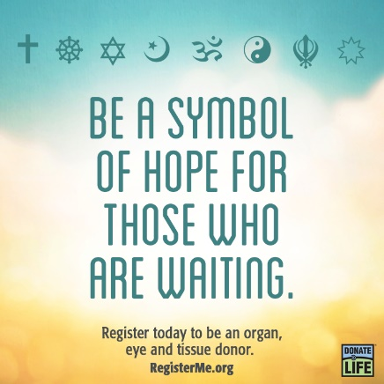

Suggested Bulletin Text
November marks Donor Sabbath, a time when we recognize the importance of organ donation. Organ donation is an incredible act of generosity and charity. One person can save up to eight lives and leave a lasting legacy. Pikuach Nefesh (saving a life) is such a sacred principle that it takes precedence over almost every other religious act or consideration. Because a single organ donor can save up to eight lives, and one tissue donor can save or enhance the lives of up to 50 people, Judaism views organ and tissue donation as a sacred act of Pikuach Nefesh which overrides all other religious concerns, such as burying a body intact and expedient burial. Nearly 10,000 of our fellow New Yorkers are waiting for a lifesaving organ transplant and there are not enough donors. Please consider signing up to save a life. To learn more, visit LiveOnNY.org/Judaism.

Suggested Prayer
The Strength to Give: A Prayer for Organ Donation
Rock of Ages, Almighty God...
give us strength!
Give strength to those awaiting transplantation,
whose bodies betray them,
whose spirit abandons them, waiting, hoping, praying...
for the gift of life.

Give strength to the relatives and friends
of those awaiting transplantation,
who dearly love them,
who steadfastly care for them,
waiting, hoping, praying...
for the gift of life.

Give strength to the grieving families
considering organ donation.
Help them find comfort in the power
to end the wait,
to fuel the hope,
to answer the prayers...
by saying ‘yes’ to the gift of life.

Rock of Ages, Almighty God,
give our loved ones the strength to Live On...
through the miracle of transplantation
and the legacy of organ donation.

